Current Future Land Use Intensity Matrix (Page 61, RE; Imagine Land Use, Wagoner Comprehensive Plan)
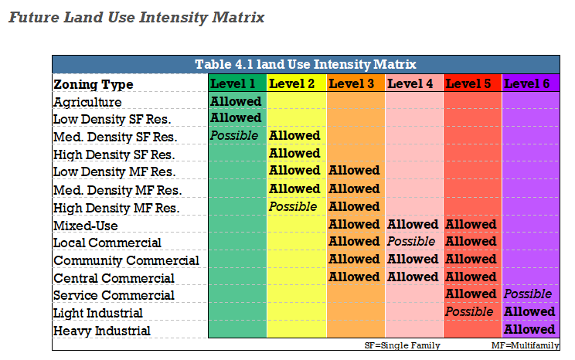

Proposed Future Land Use Intensity Matrix (Page 61, RE; Imagine Land Use, Wagoner Comprehensive Plan)
